CASE STUDY 1 (MONGODB)

ADD DATA INTO DB
db.products.insertMany([
{
"id": "1",
"product_name": "Intelligent Fresh Chips",
"product_price": 655.00,
"product_material": "Concrete",
"product_color": "mint green"
},
{
"id": "2",
"product_name": "Practical Fresh Sausages",
"product_price": 911.0,
"product_material": "Cotton",
"product_color": "indigo"
},
{
"id": "3",
"product_name": "Refined Steel Car",
"product_price": 690.00,
"product_material": "Rubber",
"product_color": "gold"
},
{
"id": "4",
"product_name": "Gorgeous Plastic Pants",
"product_price": 492.00,
"product_material": "Soft",
"product_color": "plum"
},
{
"id": "5",
"product_name": "Sleek Cotton Chair",
"product_price": 33.00,
"product_material": "Fresh",
"product_color": "black"
},
{
"id": "6",
"product_name": "Awesome Wooden Towels",
"product_price": 474.00,
"product_material": "Plastic",
"product_color": "orange"
},
{
"id": "7",
"product_name": "Practical Soft Shoes",
"product_price": 500.00,
"product_material": "Rubber",
"product_color": "pink"
},
{
"id": "8",
"product_name": "Incredible Steel Hat",
"product_price": 78.00,
"product_material": "Rubber",
"product_color": "violet"
},
{
"id": "9",
"product_name": "Awesome Wooden Ball",
"product_price": 28.00,
"product_material": "Soft",
"product_color": "azure"
},
{
"id": "10",
"product_name": "Generic Wooden Pizza",
"product_price": 84.00,
"product_material": "Frozen",
"product_color": "indigo"
},
{
"id": "11",
"product_name": "Unbranded Wooden Cheese",
"product_price": 26.00,
"product_material": "Soft",
"product_color": "black"
},
{
"id": "12",
"product_name": "Unbranded Plastic Salad",
"product_price": 89.00,
"product_material": "Wooden",
"product_color": "pink"
},
{
"id": "13",
"product_name": "Gorgeous Cotton Keyboard",
"product_price": 37.00,
"product_material": "Concrete",
"product_color": "sky blue"
},
{
"id": "14",
"product_name": "Incredible Steel Shirt",
"product_price": 54.00,
"product_material": "Metal",
"product_color": "white"
},
{
"id": "15",
"product_name": "Ergonomic Cotton Hat",
"product_price": 43.00,
"product_material": "Rubber",
"product_color": "mint green"
},
{
"id": "16",
"product_name": "Small Soft Chair",
"product_price": 47.00,
"product_material": "Cotton",
"product_color": "teal"
},
{
"id": "17",
"product_name": "Incredible Metal Car",
"product_price": 36.00,
"product_material": "Fresh",
"product_color": "indigo"
},
{
"id": "18",
"product_name": "Licensed Plastic Bacon",
"product_price": 88.00,
"product_material": "Steel",
"product_color": "yellow"
},
{
"id": "19",
"product_name": "Intelligent Cotton Chips",
"product_price": 46.00,
"product_material": "Soft",
"product_color": "azure"
},
{
"id": "20",
"product_name": "Handcrafted Wooden Bacon",
"product_price": 36.00,
"product_material": "Concrete",
"product_color": "lime"
},
{
"id": "21",
"product_name": "Unbranded Granite Chicken",
"product_price": 90.00,
"product_material": "Metal",
"product_color": "gold"
},
{
"id": "22",
"product_name": "Ergonomic Soft Hat",
"product_price": 99.00,
"product_material": "Rubber",
"product_color": "black"
},
{
"id": "23",
"product_name": "Intelligent Steel Pizza",
"product_price": 95.00,
"product_material": "Cotton",
"product_color": "azure"
},
{
"id": "24",
"product_name": "Tasty Rubber Cheese",
"product_price": 47.00,
"product_material": "Frozen",
"product_color": "orchid"
},
{
"id": "25",
"product_name": "Licensed Steel Car",
"product_price": 20.00,
"product_material": "Cotton",
"product_color": "indigo"
}
])

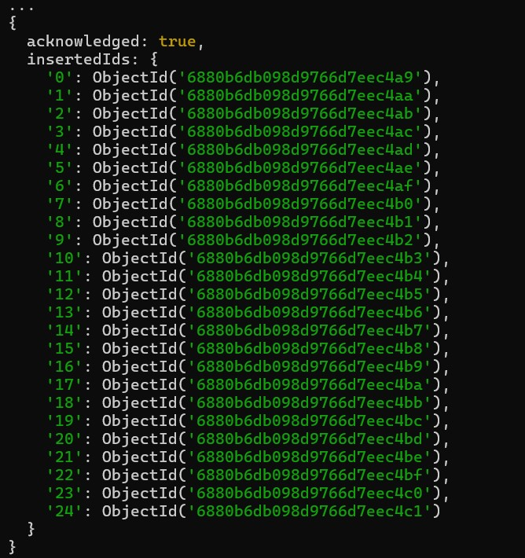

1. Find all the information about each product
db.products.find({})
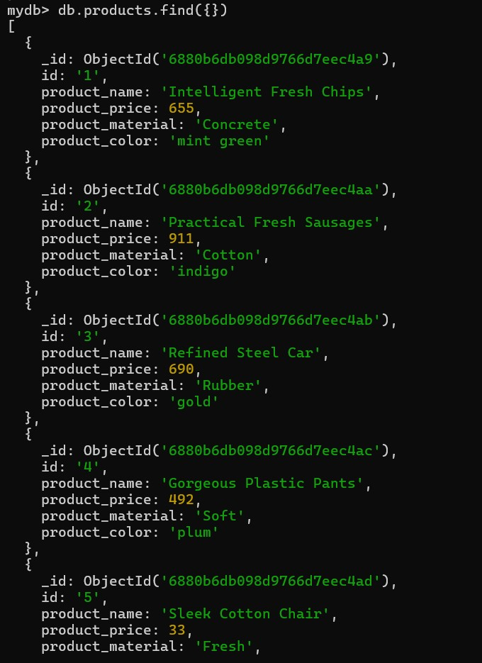

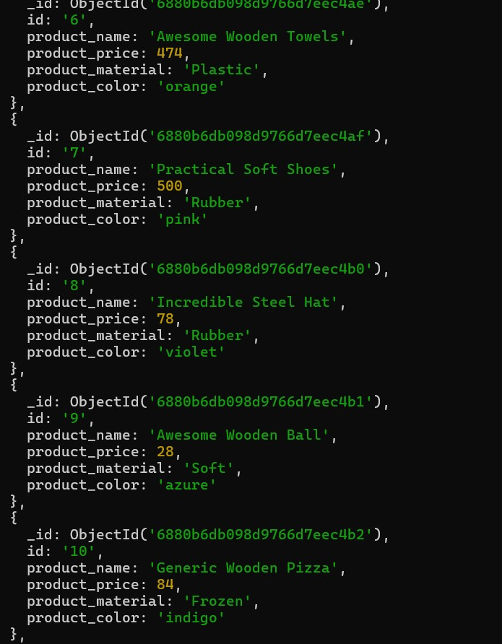
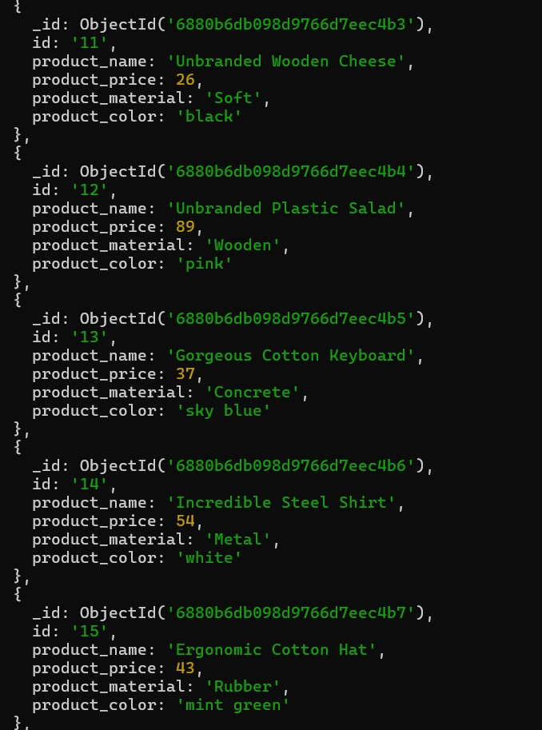

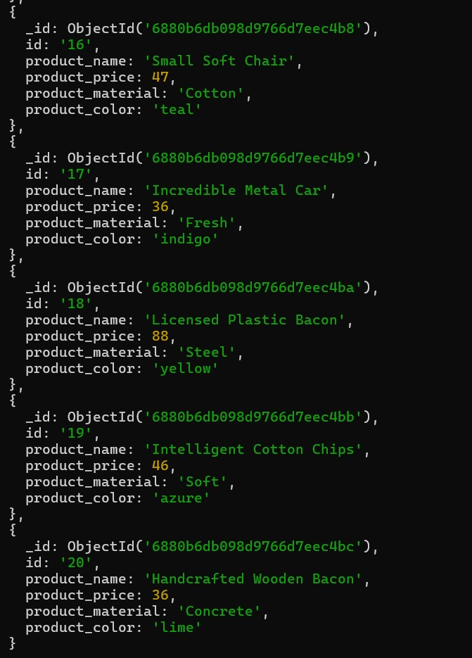

2. Find the product prices which are between 400 to 800
db.products.find(
{ product_price: { $gte: 400, $lte: 800 } },
{ product_price: 1, _id: 0 }
)
3. Find the product prices which are not between 400 to 600
db.products.find(
{ $or: [ { product_price: { $lt: 400 } }, { product_price: { $gt: 600 } } ] },
{ product_price: 1, _id: 0 }
)

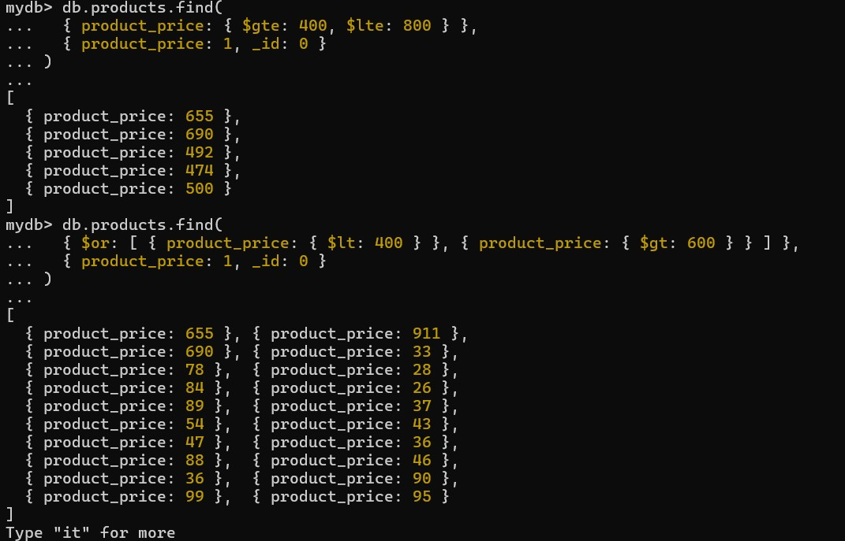

4. List the four products which are greater than 500 in price
db.products.find(
{ product_price: { $gt: 500 } }
).limit(4)

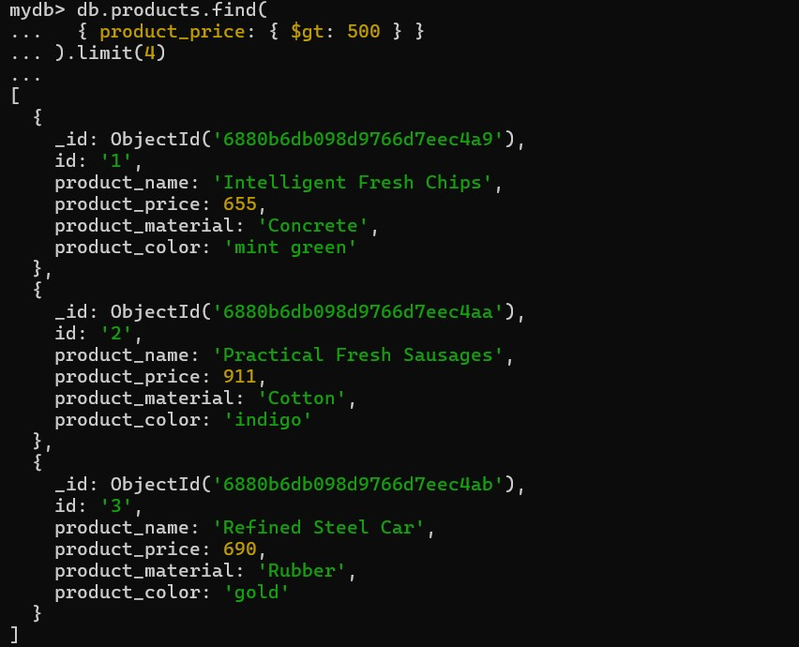

5. Find the product name and product material of each product
db.products.find(
{},
{ product_name: 1, product_material: 1, _id: 0 }
)

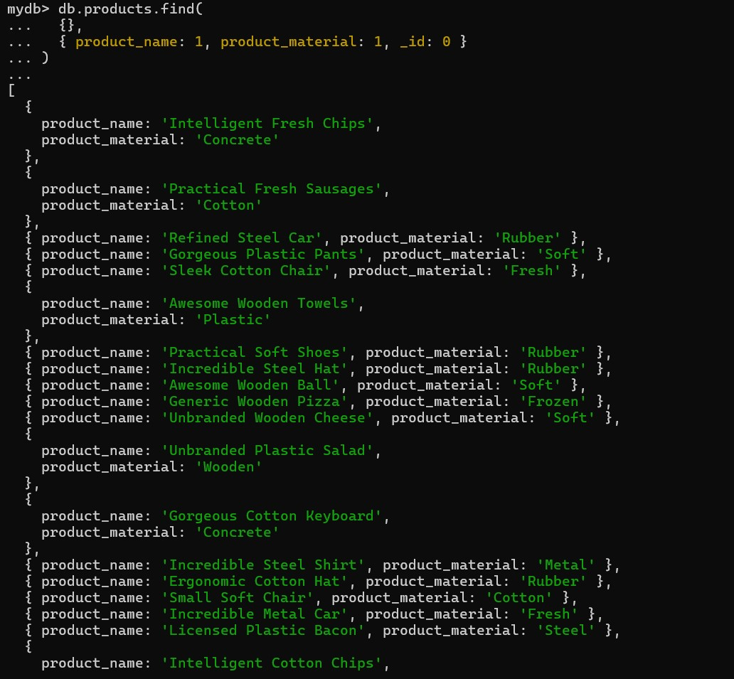

6. Find the product with a row id of 10
db.products.find(
{ id: "10" }
)
